Git:
- Create remote repository.
- Sign in to https://github.com/login with username and password.
- Create new – New repository
- Repository Name - SecondProject_React_Frontend_Development
- Click “Create Repository”

URL - https://github.com/Shruthi-Karunya/React_Frontend_Development.git

- Create Local repository.
- Go to D drive and create a folder ReactJSON_Frontend_Development
- Open command prompt and go to above folder ReactJSON_Frontend_Development
- Type command “git init” to initialize local directory.
- Stage files (we don’t have anything yet) with command – “git add .”
- Commit the staged file files (we don’t have anything yet) with command – “git commit -m “Initial commit”

- Connect Remote repository to local repository.
- Type command “git remote add origin “https://github.com/Shruthi-Karunya/React_Frontend_Development.git”” from command prompt and within directory ReactJSON_Frontend_Development
- Type “git remote -v” to know remote repository URL (fetch and push)
- Created and saved document “Project_flow_documentation_React” at local directory D:\ ReactJSON_Frontend_Development
This document explains detailed project work.
- git add .
- git commit -m “initial commit1”
- git push -u origin master (while master is the working branch name. To get current branch run “ git branch” command.
- Now file Project_flow_documentation is pushed to remote repository.

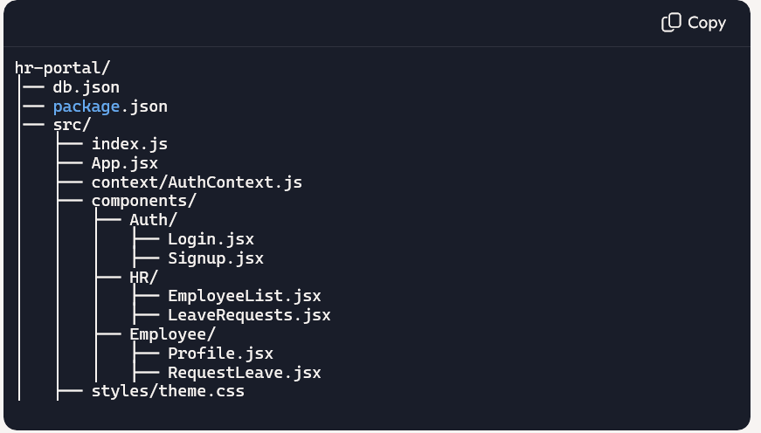

Db.json
{
"users": [
{ "id": 1, "fname": "John", "lname": "Doe", "email": "john@abc.com", "password": "1234", "role": "employee" },
{ "id": 2, "fname": "Jane", "lname": "Smith", "email": "jane@hr.com", "password": "abcd", "role": "hr" }
],
"employees": [
{ "id": 1, "fname": "John", "lname": "Doe", "age": 30, "email": "john@abc.com" }
],
"leaves": [
{ "id": 1, "employeeId": 1, "status": "pending", "reason": "Medical" }
]
}

Run JSON Server:
npx json-server --watch db.json --port 5000

AuthContext.js
import { createContext, useState } from "react";

export const AuthContext = createContext();

export const AuthProvider = ({ children }) => {
const [user, setUser] = useState(null);

const login = (userData) => setUser(userData);
const logout = () => setUser(null);

return (
<AuthContext.Provider value={{ user, login, logout }}>
{children}
</AuthContext.Provider>
);
};
Login.jsx:

// src/components/Auth/Login.jsx
import { useState, useContext } from "react";
import { AuthContext } from "../../context/AuthContext";

export default function Login() {
const { login } = useContext(AuthContext);
const [email, setEmail] = useState("");
const [password, setPassword] = useState("");

const handleSubmit = async (e) => {
e.preventDefault();
const res = await fetch(`http://localhost:5000/users?email=${email}&password=${password}`);
const data = await res.json();
if (data.length > 0) login(data[0]);
else alert("Invalid credentials");
};

return (
<form onSubmit={handleSubmit} className="card">
<h2>Login</h2>
<input type="email" placeholder="Email" value={email} onChange={(e)=>setEmail(e.target.value)} />
<input type="password" placeholder="Password" value={password} onChange={(e)=>setPassword(e.target.value)} />
<button type="submit">Login</button>
</form>
);
}

Signup.jsx:
// src/components/Auth/Signup.jsx
import { useState } from "react";

export default function Signup() {
const [form, setForm] = useState({ fname:"", lname:"", age:"", email:"", password:"", role:"employee" });

const handleChange = (e) => setForm({ ...form, [e.target.name]: e.target.value });

const handleSubmit = async (e) => {
e.preventDefault();
await fetch("http://localhost:5000/users", {
method: "POST",
headers: { "Content-Type": "application/json" },
body: JSON.stringify(form)
});
alert("Signup successful!");
};

return (
<form onSubmit={handleSubmit} className="card">
<h2>Sign Up</h2>
<input name="fname" placeholder="First Name" onChange={handleChange} />
<input name="lname" placeholder="Last Name" onChange={handleChange} />
<input name="age" type="number" placeholder="Age" onChange={handleChange} />
<input name="email" type="email" placeholder="Email" onChange={handleChange} />
<input name="password" type="password" placeholder="Password" onChange={handleChange} />
<button type="submit">Sign Up</button>
</form>
);
}
App.jsx
import { BrowserRouter as Router, Routes, Route, Navigate } from "react-router-dom";
import { useContext } from "react";
import { AuthContext } from "./context/AuthContext";
import Login from "./components/Auth/Login";
import Signup from "./components/Auth/Signup";
import EmployeeList from "./components/HR/EmployeeList";
import LeaveRequests from "./components/HR/LeaveRequests";
import Profile from "./components/Employee/Profile";
import RequestLeave from "./components/Employee/RequestLeave";
import "./styles/theme.css";

function ProtectedRoute({ children, role }) {
const { user } = useContext(AuthContext);
if (!user) return <Navigate to="/login" />;
if (role && user.role !== role) return <Navigate to="/" />;
return children;
}

export default function App() {
return (
<Router>
<Routes>
<Route path="/" element={<Navigate to="/login" />} />
<Route path="/login" element={<Login />} />
<Route path="/signup" element={<Signup />} />

{/* HR Routes */}
<Route path="/hr/employees" element={
<ProtectedRoute role="hr"><EmployeeList /></ProtectedRoute>
} />
<Route path="/hr/leaves" element={
<ProtectedRoute role="hr"><LeaveRequests /></ProtectedRoute>
} />

{/* Employee Routes */}
<Route path="/employee/profile" element={
<ProtectedRoute role="employee"><Profile /></ProtectedRoute>
} />
<Route path="/employee/request-leave" element={
<ProtectedRoute role="employee"><RequestLeave /></ProtectedRoute>
} />
</Routes>
</Router>
);
}

Theme.css
body { font-family: Arial, sans-serif; background: #f4f6f8; margin: 0; }
.card { background: white; padding: 20px; margin: 20px auto; border-radius: 8px; width: 300px; box-shadow: 0 4px 8px rgba(0,0,0,0.1); }
input, select, button { margin: 8px 0; padding: 10px; width: 100%; border-radius: 5px; border: 1px solid #ccc; }
button { background: #4CAF50; color: white; border: none; cursor: pointer; font-weight: bold; }
button:hover { background: #45a049; }
h2 { text-align: center; color: #333; }
a { color: #007BFF; text-decoration: none; }
a:hover { text-decoration: underline; }

EmployeeList.jsx:
// src/components/HR/EmployeeList.jsx
import { useEffect, useState } from "react";

export default function EmployeeList() {
const [employees, setEmployees] = useState([]);

useEffect(() => {
fetch("http://localhost:5000/employees")
.then(res => res.json())
.then(setEmployees);
}, []);

const deleteEmployee = async (id) => {
await fetch(`http://localhost:5000/employees/${id}`, { method: "DELETE" });
setEmployees(employees.filter(e => e.id !== id));
};

return (
<div className="card">
<h2>Employee Records</h2>
{employees.map(emp => (
<div key={emp.id} style={{ marginBottom: "10px" }}>
<p>{emp.fname} {emp.lname} ({emp.age})</p>
<p>Email: {emp.email}</p>
<button onClick={() => deleteEmployee(emp.id)}>Delete</button>
</div>
))}
</div>
);
}
Profile.jsx:
// src/components/Employee/Profile.jsx
import { useEffect, useState, useContext } from "react";
import { AuthContext } from "../../context/AuthContext";

export default function Profile() {
const { user } = useContext(AuthContext);
const [profile, setProfile] = useState(user);

useEffect(() => {
setProfile(user);
}, [user]);

const handleChange = (e) => setProfile({ ...profile, [e.target.name]: e.target.value });

const saveProfile = async () => {
await fetch(`http://localhost:5000/employees/${user.id}`, {
method: "PUT",
headers: { "Content-Type": "application/json" },
body: JSON.stringify(profile)
});
alert("Profile updated!");
};

return (
<div className="card">
<h2>My Profile</h2>
<input name="fname" value={profile.fname} onChange={handleChange} />
<input name="lname" value={profile.lname} onChange={handleChange} />
<input name="age" value={profile.age} onChange={handleChange} />
<input name="email" value={profile.email} onChange={handleChange} />
<button onClick={saveProfile}>Save</button>
</div>
);
}
LeaveRequests.jsx:
// src/components/HR/LeaveRequests.jsx
import { useEffect, useState } from "react";

export default function LeaveRequests() {
const [leaves, setLeaves] = useState([]);

useEffect(() => {
fetch("http://localhost:5000/leaves")
.then(res => res.json())
.then(setLeaves);
}, []);

const updateStatus = async (id, status, reason) => {
await fetch(`http://localhost:5000/leaves/${id}`, {
method: "PATCH",
headers: { "Content-Type": "application/json" },
body: JSON.stringify({ status, reason })
});
setLeaves(leaves.map(l => l.id === id ? { ...l, status, reason } : l));
};

return (
<div className="card">
<h2>Leave Requests</h2>
{leaves.map(l => (
<div key={l.id} style={{ marginBottom: "10px" }}>
<p>Employee ID: {l.employeeId}</p>
<p>Status: {l.status}</p>
<button onClick={() => updateStatus(l.id, "approved", "Approved by HR")}>Approve</button>
<button onClick={() => updateStatus(l.id, "rejected", "Rejected by HR")}>Reject</button>
</div>
))}
</div>
);
}

RequestLeave.jsx:
// src/components/Employee/RequestLeave.jsx
import { useState, useContext } from "react";
import { AuthContext } from "../../context/AuthContext";

export default function RequestLeave() {
const { user } = useContext(AuthContext);
const [reason, setReason] = useState("");

const submitLeave = async (e) => {
e.preventDefault();
await fetch("http://localhost:5000/leaves", {
method: "POST",
headers: { "Content-Type": "application/json" },
body: JSON.stringify({ employeeId: user.id, status: "pending", reason })
});
alert("Leave request submitted!");
setReason("");
};

return (
<form onSubmit={submitLeave} className="card">
<h2>Request Leave</h2>
<textarea
placeholder="Reason for leave"
value={reason}
onChange={(e) => setReason(e.target.value)}
style={{ padding: "10px", borderRadius: "5px", border: "1px solid #ccc" }}
/>
<button type="submit">Submit</button>
</form>
);
}
How to Run
- Create project:
npx create-react-app hr-portal
cd hr-portal

- Replace src/ with the structure above.
- Add db.json at root.
- Install dependencies:
npm install react-router-dom

- - Run JSON Server:
npx json-server --watch db.json --port 5000
- Start React app:
npm start

